13 January 2020

Alrewas
Burton On Trent
Staffs

Dear ,

Anson Road regeneration scheme

We hope that you had an enjoyable Christmas and New Year and are keeping well. We wanted to update you on the regeneration of Anson Road.

Unfortunately, it has taken longer than we had expected to finalise the necessary legal agreements with the Local Authority to enable works to begin. As a result, we will not be able to start on site by February as we had previously hoped. We do not have a start date for construction at present but estimate that it will be at least three months from today’s date. The road will remain closed during this period.

We appreciate these ongoing delays are very frustrating and would like to thank you for your patience. Please be assured that we are doing everything we can to move the development forward and will keep you informed of any progress.

If you have any queries or wish to discuss anything please contact us on the telephone numbers or email addresses below.

Yours sincerely,

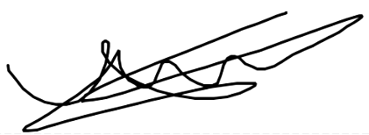
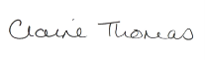
Claire Thomas James Trotter
Regeneration Manager Regeneration Co-ordinator

T: 01989 730493 M: 07976086134
M: 07979 707156
Email: claire.thomas@bromford.co.uk Email: james.trotter@bromford.co.uk

